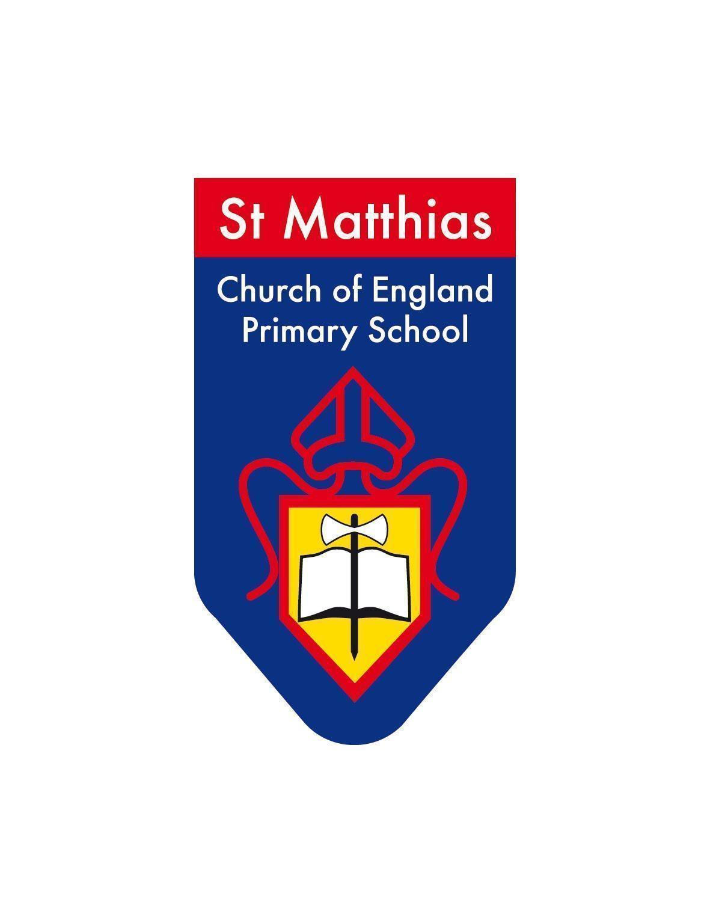
St Matthias Church of England Primary School

Wordsworth Rd, London N16 8DD
Tel: 0207 254 1148 • Fax: 0207 275 9215 • Email: admin@st-matthias.hackney.sch.uk
Executive Principal: Sian Davies • Head Teacher: Lucy Blewett

Friday 21st November

Dear Parents/Carers,

We are thrilled to share that we have managed to secure fully funded trips to the Lee Valley Ice Skating Rink. Children in Year 2-Year 6 will enjoy a special pre-Christmas treat, ice-skating with their class! This free trip will be available for all children who show brilliant learning and behaviour right up until the end of this half term.

Tuesday 16th December - Year 2
Departing at 10am, returning to school at 1pm
Children do NOT need a packed lunch for this trip.
Children will eat lunch when they return to school.

Tuesday 16th December - Year 3 & Year 4
Departing at 11am, returning to school at 2pm
A packed lunch is needed for this trip.
The school will provide one for every child; children can bring their own healthy packed lunch.

Wednesday 17th December - Year 5 & Year 6
Departing at 11am, returning to school at 2pm
A packed lunch is needed for this trip.
The school will provide one for every child; children can bring their own healthy packed lunch.

Your child will need to bring the following items to school on the day of their trip:
- A thick coat
- Gloves
- A thick pair of socks

We do have some spaces for adults to join this trip. Please talk to your child’s teacher if you would like to attend!

Please let me know if you have any questions.
Yours sincerely,
Amy Frohock
Deputy Headteacher

Primary Advantage - Schools Achieving More Together

